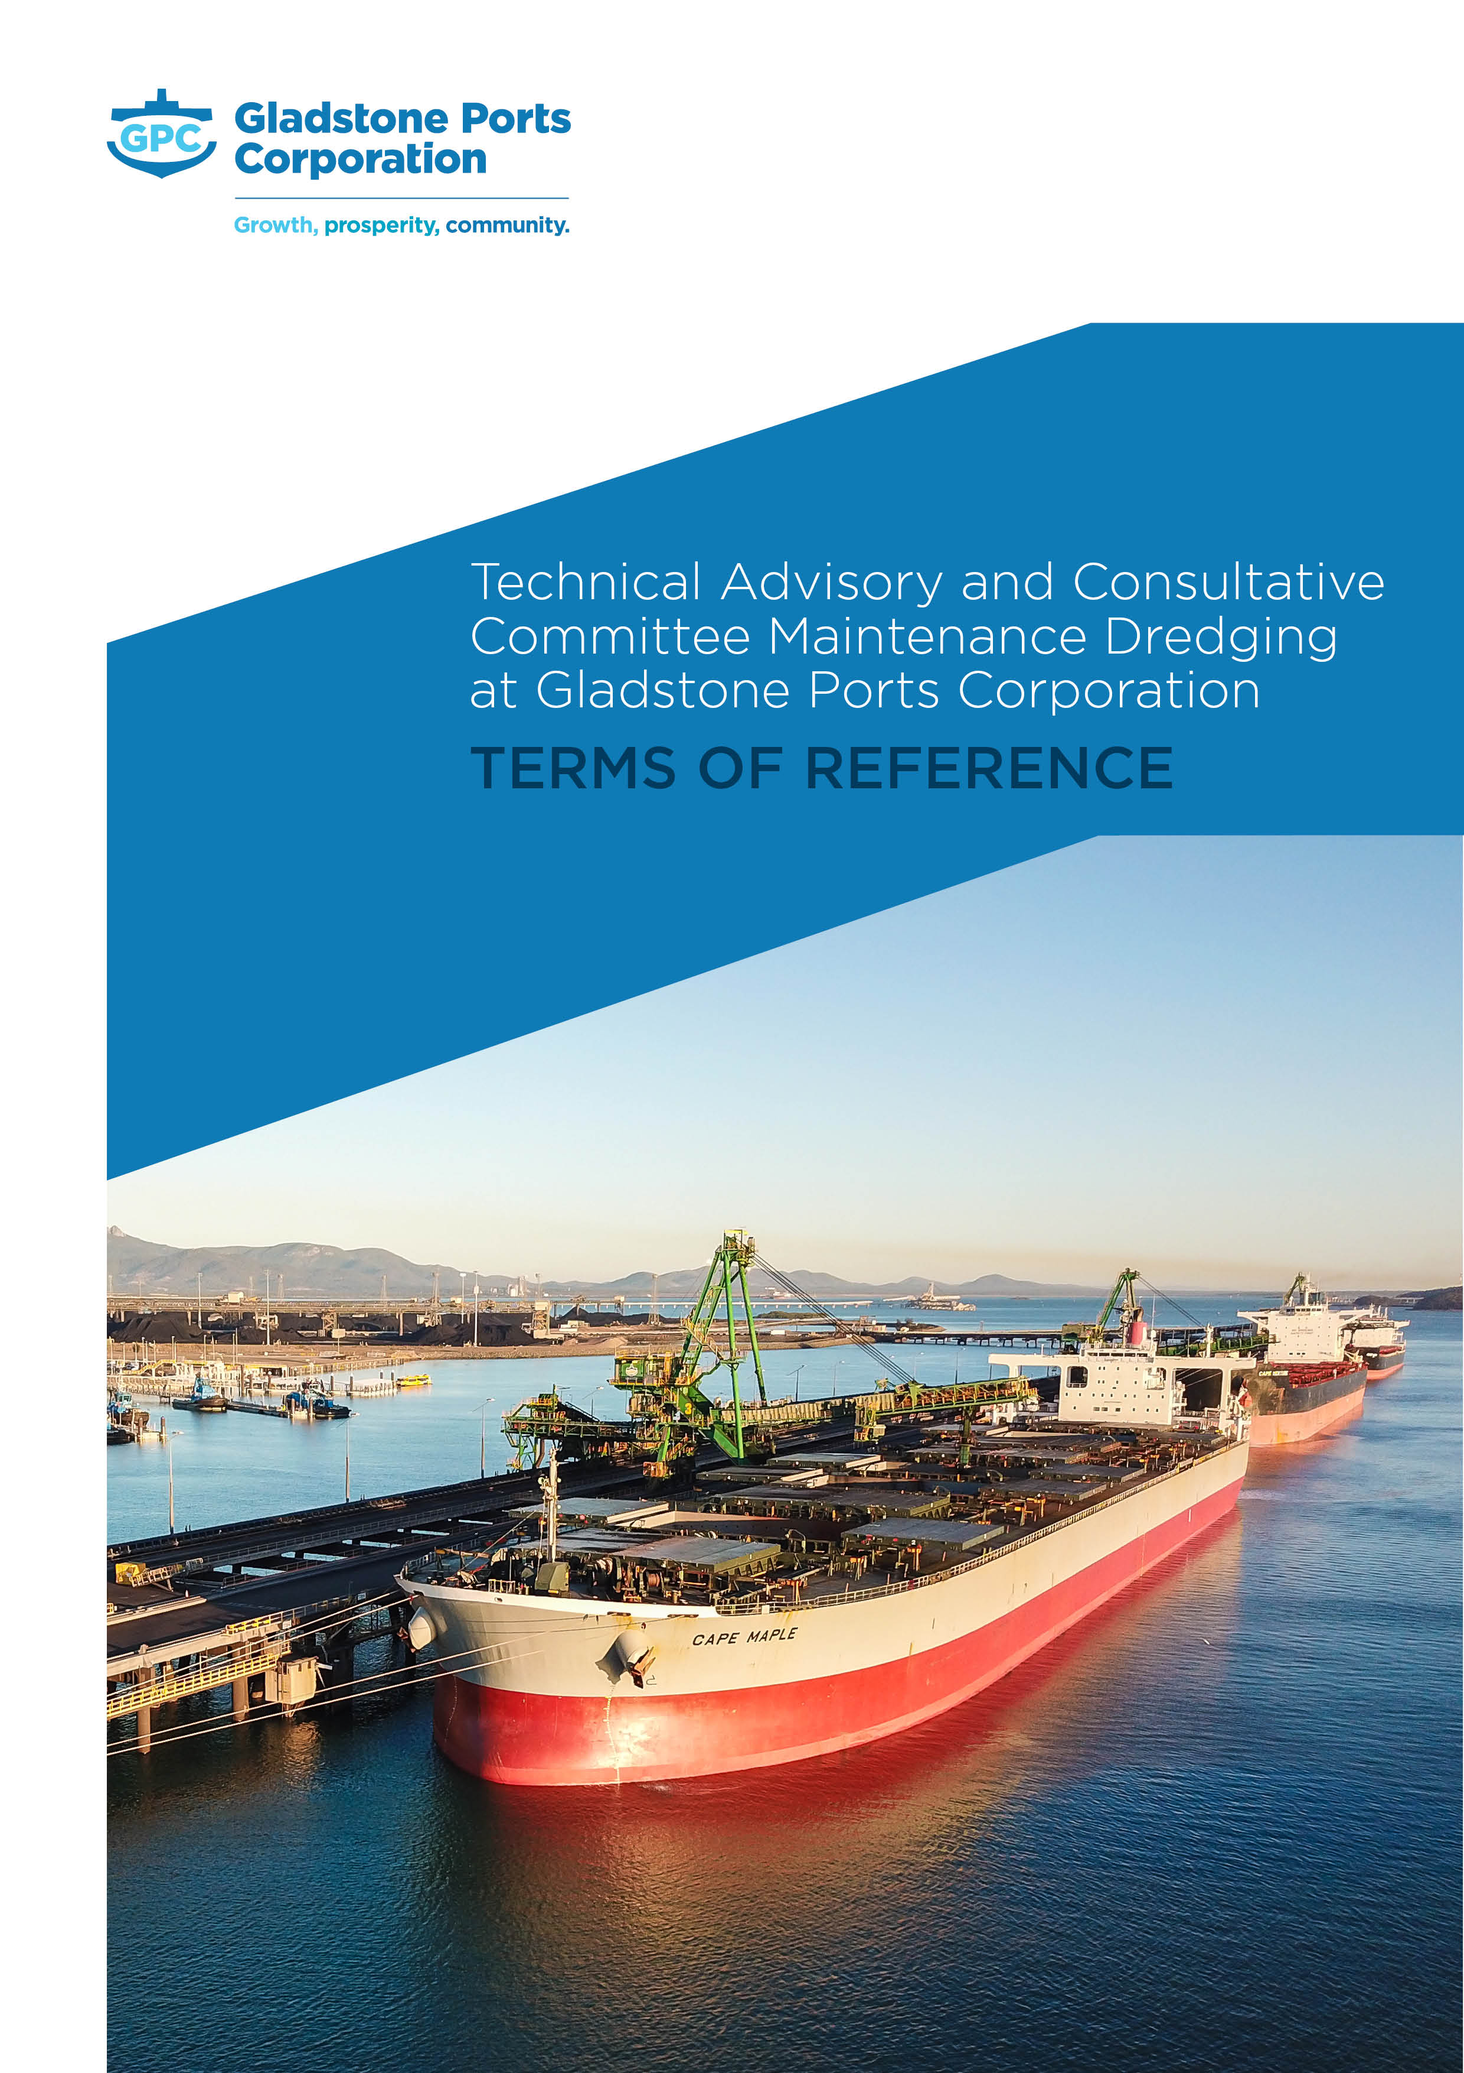

Table of Contents

Table of Contents 2
1 Context 3
2 Scope and Objectives 4
3 GPC Custodian and Chair 4
4 Members 5
4.1 Proposed Gladstone TACC Membership 5
4.2 Proposed Bundaberg TACC Membership 6
4.3 Contact Details 6
5 Membership Responsibilities 6
6 Meetings 7
7 Agenda and Minutes 7
8 Communication 7
9 Review 8

1 Context
Gladstone Ports Corporation (GPC) has established Technical Advisory and Consultative Committees (TACC) for the Port of Gladstone and Port of Bundaberg maintenance dredging activities. Maintenance dredging is generally undertaken annually at each of these Ports. Currently, there is no maintenance dredging requirement for the Port of Rockhampton and hence no need for a TACC.
In alignment with the Maintenance Dredging Strategy 2016 (MDS), membership of GPC’s TACCs are drawn from relevant Commonwealth, State and Local Government, Non-Government Organisations, and community groups with expertise, responsibilities or an interest in the dredging activities at GPC ports. Membership is also guided by the Long Term Maintenance Dredging Management Plan Guidelines 2018 (LMDMP Guideline) and the National Assessment Guidelines for Dredging 2009 (NAGD).
The LMDMP guideline reiterates that to ensure good outcomes are achieved it is important that the members of a TACC have appropriate representation with sufficient skills and expertise. TACC function and effectiveness is enhanced by transparency in membership, mandate, access to information during meetings and upon request, consensus forming and reporting mechanisms, minutes or communiques, and by the transparency of GPC’s responses to TACC recommendations as detailed in this Terms of Reference (ToR).
Therefore, TACCs are important consultative mechanisms intended to ensure that interested stakeholders have a forum to understand GPC’s maintenance dredging activities and to assist GPC and regulatory agencies to access local knowledge and reconcile stakeholder interests.

2 Scope and Objectives
An effective TACC is acknowledged as best practice maintenance dredging management by the Queensland Government for Great Barrier Reef World Heritage Area Ports under the MDS.
The Department of Transport and Main Roads (TMR) guidelines for LMDMPs recognise that a TACC is an appropriate mechanism for ports to engage with stakeholders as part of the development and oversight of LMDMPs.
The TACC focus is on providing external advice to GPC on environmental, social and economic issues and as a way of ensuring representation of a broad range of stakeholder interests in the decision-making process. The Queensland Government expects that ports will utilise TACCs both during and after the development of LMDMPs including:
- Early engagement with TACCs to gain an understanding of the values that are important to stakeholders.
- TACC participation in the comparative analysis process, enabling stakeholder consideration and feedback on the options development process to determine and assess the alternatives and assist in determining the most appropriate option.
- TACCs will review the performance and effectiveness of specific dredging campaigns, consider key learnings from the review and provide advice on whether the LMDMP requires updating to reflect any of these learnings. This will enable ports to understand, from a stakeholder’s point of view, how effective the options chosen were and whether there are better ways of undertaking dredging activities in the future.
- TACC participation in the updating and renewal of LMDMPs to ensure LMDMPs reflect any learnings or improvements identified during dredging campaigns.
- The TACCs can be used by ports to consider and respond to any concerns raised following the finalisation of the LMDMP including those raised by the general public.

The NAGD also provides guidance on the purpose, scope and membership of TACCs. The information GPC gains from the TACC is essential to the sustainability of maintenance dredging operations. In accordance with the NAGD, the TACCs are intended to:
- Provide continuity of direction and effort in protecting the local environment.
- Aid communication between stakeholders and provide a forum where points of view can be discussed and conflicts resolved.
- Assist in the establishment, as appropriate, of longer term permitting arrangements, including the development and implementation of LMDMPs, research, sampling and monitoring programs.
- Review ongoing management of maintenance dredging and disposal activities.
- Make recommendations to the proponent GPC and the regulatory agencies as necessary or appropriate.

3 GPC Custodian and Chair
The Port Infrastructure Asset Manager and the Port of Bundaberg Manager are the custodian of the Port of Gladstone and Port of Bundaberg TACCs respectively and are responsible for the implementation of this ToR.
GPC will Chair the meetings and is responsible for ensuring the members are informed of all relevant information in a timely manner so that they can undertake their functions and responsibilities.
The Chair will invite relevant specialists to attend meetings that the members, or Chair, deem necessary to facilitate informed discussions when required.

4 Members
Membership is linked to organisations or groups rather than individuals. To ensure beneficial outcomes are achieved it is important that the members of a TACC have appropriate representation with sufficient skills and expertise.
TACC member organisations / groups will be selected by GPC in accordance with guidance provided by the NAGD, the MDS and the LMDMP guidelines, presented as Section 4.1 - Proposed Gladstone TACC Membership and Section 4.2 – Proposed Bundaberg TACC Membership.
If no response or decline is received from a proposed member organisation after formal invitation, then it is deemed that they do not wish to participate in the TACC. GPC will keep records of membership correspondence and maintain the TACC Contact Details Register (#1433833) as the key source of membership information.
Each organisation is to provide GPC with representative details of who will be attending on behalf of their organisation. If a proxy is required, then the proxy member shall also provide these details. If the representative or proxy changes, it is the organisations responsibility to write to the TACC Chair of the change.
Non-attendance from a member without apology for more than three (3) consecutive meetings is deemed that the organisation does not wish to participate in the TACC. Under these circumstances the member will be removed from the active member list.
In the event of member resignation, the members must resign in writing to the Chair. The organisation will then be taken off the active membership list TACC Contact Details Register (#1433833). If the member wishes to be re-considered for TACC membership this request should be made in writing to the TACC Chair and acceptance will be at the discretion of GPC.
Changes to membership are at GPC’s discretion or as a result of non-conformance with Membership Responsibilities (Section 5) and will be communicated at the following TACC meeting.
  - Proposed Gladstone TACC Membership
Commonwealth Government Members:
- Australian Fisheries Management Authority (AFMA)
- Department of Agriculture and Fisheries (DAF)
- Australian Hydrographic Service (AHS)
- Australian Maritime Safety Authority (AMSA)
- Department of Agriculture and Water – Biosecurity (AWE)
- Department of Agriculture and Water – Sea Dumping (AWE)
- Great Barrier Reef Marine Park Authority (GBRMPA)

State Government Members:
- Department of Agriculture and Fisheries (DAF)
- Department of Environment and Science (DES)
- Department of Transport and Main Roads (TMR)
- Maritime Safety Queensland (MSQ)

Local Government and Non-Government Members:
- Central Queensland University (CQU)
- Commercial Fishermen (QSI)
- Gladstone Area Promotion and Development Limited (GAPDL)
- Gladstone Chamber of Commerce
- Gladstone Conservation Council (GCC)
- Gladstone Healthy Harbour Partnership (GHHP)
- Gladstone Industry Leadership Group (GILG)
- Gladstone Regional Council (GRC)
- James Cook University (JCU)
- Local Marine Advisory Committee (LMAC)
- Port Curtis Integrated Monitoring Program (PCIMP)
- Recreational Fishermen (GSF)
- Traditional Owners - Port Curtis Coral Coast People (PCCC)
- Volunteer Marine Rescue Gladstone (VMR)
  - Proposed Bundaberg TACC Membership
Commonwealth Government Members:
- Australian Fisheries Management Authority (AFMA)
- Department of Agriculture and Fisheries (DAF)
- Australian Hydrographic Service (AHS)
- Australian Maritime Safety Authority (AMSA)
- Department of Agriculture and Water – Biosecurity (AWE)
- Department of Agriculture and Water – Sea Dumping (AWE)

State Government Members:
- Department of Agriculture and Fisheries (DAF)
- Department of Environment and Science (DES)
- Department of Transport and Main Roads (DTMR)
- Aquatic Threatened Species, Department of Environment and Sciences Operations / QPWS & Patnerships
- Maritime Safety Queensland (MSQ)

Local Government and Non-Government Members:
- Bundaberg Birdlife Inc.
- Bundaberg Chamber of Commerce
- Bundaberg Regional Council (BRC)
- Bundaberg Tourism
- Central Queensland University (CQU)
- Commercial Fishermen (QSI)
- Burnett Local Marine Advisory Committee (LMAC)
- Recreational Fishermen (BSC)
- Traditional Owners - Port Curtis Coral Coast People (PCCC)
- Volunteer Marine Rescue Bundaberg (VMR)
- Burnett Mary Regional Group (BMRG)
- James Cook University (JCU)
- Sea Turtle Alliance
  - Contact Details
TACC members, including member’s representative’s and proxy details and any correspondence in regards to membership acceptance are contained within the TACC Contact Details Register (#1433833).

5 Membership Responsibilities
Members Representatives and their proxy will have the following responsibilities:
- Read, understand and agree to these ToR.
- Behave with respect.
- Disclose any relevant conflicts of interest.
- Maintain confidentiality as directed by the Chair.
- Advocate for the continual improvement and sustainability of GPC’s maintenance dredging activities.
- Openly participate in engagement and collaborate with GPC.

6 Meetings
The TACC will meet annually, generally following the annual maintenance dredging campaign, although additional meetings will be held as appropriate. GPC will communicate, from time to time with the group throughout the year.
Attendance at meetings may be in-person or via available electronic means (e.g. tele / video conference). GPC will keep a record of attendance and apologies. Only nominated representatives or their proxy are able to attend the meeting on behalf of the Member organisation – Refer to Section 4 - Members.

7 Agenda and Minutes
Notification of the date, time and location of meetings, and a call for agenda items will occur at least ten (10) business days prior to the meeting by the Chair (or delegate).
The TACC meetings will have a static agenda as follows:
Agenda | GPC Contributor
Meeting opened by Chair  - Purpose  - Welcome to country | Port Infrastructure Asset Manager or delegate (Gladstone)  Port of Bundaberg Manager (Bundaberg)
Admin protocols:  - Attendees & Apologies,  - Conflicts of Interest  - Safety & Amenities protocols  - Teleconferencing protocols | Port Infrastructure Asset Manager or delegate (Gladstone)  Port of Bundaberg Manager (Bundaberg)
Actions from previous meeting | Port Infrastructure Asset Manager or delegate (Gladstone)  Port of Bundaberg Manager (Bundaberg)
TOR and TACC Recap | Environment Superintendent or delegate
LMDMP status update | Environment Superintendent or delegate
Operational update | Port Infrastructure Asset Manager or delegate (Gladstone)  Port of Bundaberg Manager (Bundaberg)
Environmental performance update | Environment Superintendent or delegate
Additional items | To be determined and endorsed by Chair
Meeting closed by Chair | Port Infrastructure Asset Manager or delegate (Gladstone)  Port of Bundaberg Manager (Bundaberg)

Draft meeting minutes will be distributed to all TACC members within ten (10) business days of each meeting for a review period of ten (10) business days.
Following the consideration of any feedback provided during the review period, formal acceptance of the finalised minutes will occur via email correspondence, asking members to accept the finalised minutes. GPC will then publish the finalised minutes on its website.

8 Communication
Members acknowledge that their organisation / group name will be published as part of the publicly available meeting minutes. No representative or proxy names will be detailed in the minutes.
GPC has developed this engagement and communication strategy for its TACCs with the goal of understanding what values are important to members and to use this stakeholder input to manage maintenance dredging activities in a transparent and sustainable way. This strategy aims to ensure engagement is done meaningfully, balancing operational needs, continual improvement and the continuity of GPC’s maintenance dredging operations.
GPC will communicate directly with the TACC via GPC website updates, and from time to time email, share files and meetings. Members are expected to communicate within their own organisations or stakeholder groups to ensure a collective understanding of GPC’s dredging activities and gather relevant input for future meetings, whilst staying cognisant of the responsibilities of members mentioned above in Section 4.
All communication with the wider community or media regarding the TACC will be undertaken by GPC, unless GPC advises otherwise. Information related to the TACC for the broader audience will be made available on GPC’s corporate website.

9 Review
GPC will review the TACC ToR in conjunction with members at a minimum of every two (2) years, including membership.

